DS.140 Integration Design Specification



Fortis Layer Cost Integration

Author: Nidhi Siotia

Creation Date: Feb 19, 2024

Last Updated: Feb 19, 2024

Version: 1.1

**Approvals:**

|  |  |
| --- | --- |
| <Approver 1> | <Rakesh Khanna / Naushad / Amit> |
| <Approver 2> | <Business Owner> |

# Document Control

## Change Record

| Date | Author | Version | Change Reference |
| --- | --- | --- | --- |
| 20-Feb-2024 | Nidhi Siotia | 1.0 | No Previous Document |
|  |  |  |  |
|  |  |  |  |

2

## Reviewers

| Name | Position |
| --- | --- |
| FHL Business | Business User |
| FHL IT Group | Fortis IT Team |
|  |  |
|  |  |

Contents

1 Document Control ii

1.1 Change Record ii

1.2 Reviewers ii

2 Introduction 4

2.1.1 Scope for this Document 4

2.1.2 Intended Audience 4

3 Overview 5

3.1 Business Objectives 5

3.2 Major Features 5

3.3 Glossary 5

4 High-Level Fusion Integration flow 6

5 Technical Design Details 7

5.1 OIC Services 7

5.2 Oracle PaaS DBCS components 7

5.3 Technical flow 7

6 Data FIELD Mapping 10

6.1 File format 10

6.2 Frequency 10

7 Exception handling 11

7.1 Scenarios 11

8 Assumptions / Considerations 12

9 Open and Closed Issues 13

9.1 Open Issues 13

9.2 Closed Issues 13

# Introduction

### Scope for this Document

This analysis specification document is prepared to layout the design for Fortis Layer Cost Integration.

### Intended Audience

This document is intended for the following groups to provide the action items and consideration that are required to complete the implementation of the various Supply Chain and Finance related functionalities from Oracle Fusion.

#### Fortis Business Users

This document will be helpful for Fortis Business users to understand the technical design and process change with the new structure implemented in Oracle. The business user will validate this document after the verification of the requirement.

#### PwC Technical Team

The PwC technical team will use this document as a source technical design document to develop the technical solution to implement / deploy in Oracle Fusion.

#### Fortis IT Team

The Fortis IT Team must facilitate the PwC technical team for requisite details and other elements required from Business. The Fortis IT team is also responsible to arrange and provide required technical information wherever is required.

# Overview

Fortis Healthcare Limited (FHL) is a chain of hospitals, headquartered in India. Fortis started its health care operations from Mohali where first Fortis hospital was started. Later, the hospital chain purchased the healthcare branch of the Escorts group and increased its strength in various parts of the country. The Fortis health care also operates its hospital in Vasant Kunj, Faridabad, Gurgaon. The FMRI hospital at Gurgaon is the headquarter of Fortis healthcare with all the major facilities at the hospital.

This specification document is prepared to layout the design for an integration to create scheme PO with zero price.

## Business Objectives

The following are the business objectives.

1. To have a secure, reliable, and scalable design flow to do layer cost transactions in count correction org.
2. To have a solution providing the monitoring capabilities.

## Major Features

The proposed solution will have the following features involved:

1. OIC integration invokes Layer cost BI report to find out items that have not been costed in CC Org.
2. The OIC integration then invokes a REST API to a receipt and issue transaction(qty 1) in CC Org.

## Glossary

REST

Representational State Transfer.

OIC

Oracle Integration Cloud

# High-Level Fusion Integration flow

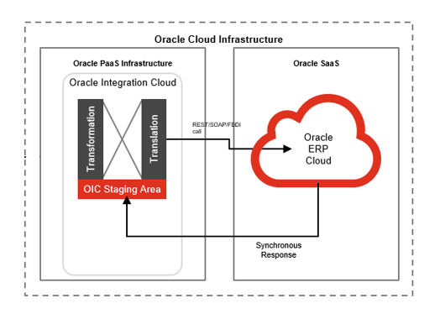

# Technical Design Details

This section describes the technical details of all the components involved in the design for Fortis Layer cost integration

## OIC Services

Following scheduled orchestration has been designed in OIC to build this integration:

|  |  |
| --- | --- |
| **OIC Integration Name** | Fortis Layer Cost Integration |
| **OIC REST Endpoint URL** | [NA](https://oic-prod-nr5lr39yailj-bo.integration.ocp.oraclecloud.com:443/ic/api/integration/v1/flows/rest/FORT_TRIG_PO_LINE_AUTO_CANC_INTG/1.0/poLineCancel/) |
| **Method** | NA |

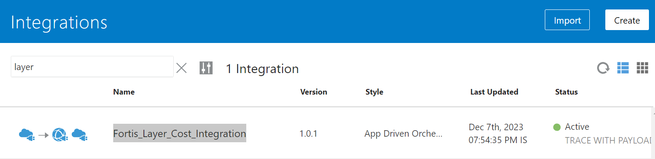

## Oracle PaaS DBCS components

This integration design does not use any DBCS related component.

## Technical flow

Following is the complete technical flow for this integration design:

1. As per the requirement, Fortis Layer Cost transactions are created only if:

* If item is costed in DTH org but no costing has been generated in count correction org as receipt transaction is missing for that item in CC org.

1. Once the scheduled OIC integration runs, it invokes a custom BIP report: /Custom/Interfaces/Integration Reports/Procurement/Fortis Layer Cost Report.xdo. This BIP report uses the following query:-

select distinct imt4.inventory_item_id,a.ITEM_NUMBER,a.PRIMARY_UOM_CODE,

imt4.organization_id ,

(

SELECT SECONDARY_INVENTORY_NAME FROM INV_SECONDARY_INVENTORIES WHERE disable_date is null

AND organization_id= imt4.organization_id

and rownum=1) SUBINVENTORY ,

(SELECT ROUND(cpc.UNIT_COST_AVERAGE,3)

FROM cst_perpavg_cost cpc,

CST_COST_ORGS_V ccov,

inv_organization_definitions_v b,

CST_COST_INV_ORGS cio,

egp_system_items_b esib

WHERE cpc.inventory_item_id = esib.inventory_item_id

and b.organization_id = esib.organization_id

AND cpc.cost_org_id = ccov.cost_org_id

AND b.organization_id = cio.inv_org_id

and cio.cost_org_id = ccov.cost_org_id

AND SYSDATE BETWEEN cpc.cost_date AND cpc.cost_end_date

and esib.inventory_item_id=imt4.inventory_item_id

and esib.organization_id=(select organization_id from INV_ORGANIZATION_DEFINITIONS_V

where organization_CODE IN(SELECT FLV.MEANING FROM FND_LOOKUP_VALUES FLV

WHERE FLV.LOOKUP_TYPE='FORTIS_ORG_CODE_LOOKUP'

AND FLV.LOOKUP_CODE=ORG1.ORGANIZATION_CODE

AND FLV.ENABLED_FLAG='Y'

AND FLV.LANGUAGE='US'

AND ROWNUM=1))

and rownum=1) unit_avg_cost

from

inv_material_txns imt4,

INV_ORGANIZATION_DEFINITIONS_V org1,

egp_system_items_b a

where

org1.organization_id=imt4.organization_id

and org1.organization_name like ('%Count Correction%')

/*and exists

(select 1

FROM inv_onhand_quantities_detail ioqd

WHERE ioqd.inventory_item_id = imt4.inventory_item_id

AND ioqd.organization_id = imt4 .organization_id)*/

AND a.inventory_item_id=imt4.inventory_item_id

and a.organization_id=imt4.organization_id

/*and not exists

(select 1 from inv_material_txns imt2

where

imt2.inventory_item_id=imt4.inventory_item_id

and imt2.organization_id=imt4.organization_id

and imt2.transaction_type_id=300000005271353)*/

and not exists

(SELECT ROUND(clc.unit_cost,3)

FROM cst_layer_costs clc,

cst_transactions ct,

cst_inv_transactions cit

WHERE clc.transaction_id = ct.transaction_id

AND ct.inventory_item_id = cit.inventory_item_id

AND ct.INVENTORY_ORG_ID = cit.INVENTORY_ORG_ID

AND cit.external_system_ref_id = to_char(imt4.transaction_id)

AND cit.external_system_reference ='FUSION'

AND cit.cst_inv_transaction_id = ct.cst_inv_transaction_id

AND cit.INVENTORY_ITEM_ID =imt4.inventory_item_id

AND cit.INVENTORY_ORG_ID = imt4.organization_id

AND rownum = 1)

1. Once OIC gets the report output, for each record we call the rest api to first create a receipt transaction of quantity 1 and then a issue transaction of quantity 1 in the same count correction org.

**Server details:**

|  |  |  |  |  |
| --- | --- | --- | --- | --- |
| **Server** | **Host name** | **Port** | **Service Name** | **Username** |
| Oracle PaaS DB | 140.238.225.129 | 1521 | PRODPDB1.fhpubsn.fhvcn.oraclevcn.com | XXFH & XXFH_RO |





# Data FIELD Mapping

NA

## File format

NA

## Frequency

The integration is scheduled to run every 120 minutes.

# Exception handling

There can be various scenarios for an error to occur. This section defines those error scenarios, and the exception handling has been done to notify and act accordingly.

## Scenarios

In a tabular format give list of scenarios and exception handling

* If any of the step or node fails within the OIC integration, Global Fault section is configured within this OIC integration to send an OIC error notification with relevant details.

# Assumptions / Considerations

The Proposed Solution will have the following technical considerations.

In the future, if any product bug arises in functionality then this process needs to be revisited after the bug is fixed.

# Open and Closed Issues

## Open Issues

| ID | Issue | Resolution | Responsibility | Target Date | Impact Date |
| --- | --- | --- | --- | --- | --- |
|  |  |  |  |  |  |
|  |  |  |  |  |  |
|  |  |  |  |  |  |
|  |  |  |  |  |  |

## Closed Issues

| ID | Issue | Resolution | Responsibility | Target Date | Impact Date |
| --- | --- | --- | --- | --- | --- |
|  |  |  |  |  |  |
|  |  |  |  |  |  |
|  |  |  |  |  |  |
|  |  |  |  |  |  |